Trade of Sheet Metalwork
Module 1: | Sheetmetal Fundamentals
Unit 8: | Tray Corner
 | Phase 2

Table of Contents
List of Figures 5
List of Tables 6
Document Release History 7
Module 1 – Sheetmetal Fundamentals 8
Unit 8 – Tray Corner 8
Learning Outcome: 8
Key Learning Points: 8
Training Resources: 9
Exercise: 9
Key Learning Points Code: 9
Procedure for Tray Assembly 10
Folding Materials 11
Folding Machines 11
Bar Folder 11
Allowance for Metal Thickness 12
Width of Folded Edge 12
Sharpness of Folded Edge 13
Box and Pan Folders 13
Fitting Forming Blades 14
Setting Angle Stop 15
Clamping 15
Forming 16
Safety Hints 17
Squeezing a Turned Edge 17
Care of the Folding Machine 18
Drawing Symbols 19
Oblique Projection 19
Isometric Projection 19
Making and Notching Simple Patterns 20
Application of Various Types of Lines 22
Dashed Lines 22
Thin Chain Lines 22
Thick Chain Lines 22
General 23
Scale Drawings 24
Scales 24
Metric 24
Imperial 24
First Angle Projection 25
Third Angle Projection 28
Terminology 29
Abbreviations 30
Drilling Maching Operation 31
Safety – Drilling Machines 31
Care of Drilling Machines 32
Pop Riveting 33
Blind Rivets 33
Forming of Rivet Head 34
Use of Lazy Tongs for Pop Riveting 34
Riveting 35
Use of Plier Riveting Tool 36
Pneumatic (air) Pop Gun 36
Self Assessment 37
Answers to Questions 1-2. Module 1.Unit 8 38
Index 39

List of Figures
Figure 1 - Tray Assembly 10
Figure 2 - Bar Folder 11
Figure 3 - Width of the Folded Edge 12
Figure 4 - Sharpness of a Folded Edge 13
Figure 5 - Box and Pan Folders 13
Figure 6 - Fitting Forming Blades 14
Figure 7 - Check Overall Width of Blades 14
Figure 8 - Setting Angle Stop 15
Figure 9 - Clamping 15
Figure 10 - Forming 1 16
Figure 11 - Forming 2 16
Figure 12 - Forming 3 16
Figure 13 - Safety Hints 17
Figure 14 - Squeezing a Turned Edge 17
Figure 15 - Techniques of Drawing - Oblique 19
Figure 16 – Techniques of Drawing - Isometric 19
Figure 17 - Take Measurements from Datum Lines 20
Figure 18 - Various Types of Lines 23
Figure 19 - Shape of the Component with a Single View 25
Figure 20 - Complete Orthographic Drawing 26
Figure 21 - First Angle Orthographic Projection 28
Figure 22 - Third Angle Orthographic Projection 28
Figure 23 - Types of Holes 29
Figure 24 - Unsafe Working 31
Figure 25 - Blind Rivets 33
Figure 26 - Forming of a Rivet Head 34
Figure 27 - Use of Plier Riveting Tool 36

List of Tables
Table 1 - Application of Various Types of Lines 22
Table 2 - Abbreviations 30

Document Release History
Date | Version | Comments
04/07/06 | First draft
07/04/14 | 2.0 | SOLAS transfer

Module 1 – Sheetmetal Fundamentals

Unit 8 – Tray Corner
Duration – 3.5 Hours

Learning Outcome:
By the end of this unit each apprentice will be able to:
- Use and care of the box and pan folders and hand drill
- Read and Interpret drawings in first and third angle orthographic projection
- Calculate blank size
- Mark-out, cut, file, drill, form and assemble tray corner

Key Learning Points:
Sk Rk | Use and care of tools, machinery and equipment, especially the box and pan folders and hand drill.
D | Read and interpret drawings in first and third angle orthographic projection.
D | Interpret drawing symbols and legend.
Sk | Mark-out, cut, file, drill, fold and assembly.
H | Safe working practices.
Rk P | Work planning, quality, control, surface defects, problem solving.
Sk | Safety edges.
H Sk | Safe use of drilling machines.
Rk | Galvanized mild steel/surface coatings/working properties.
Rk | Steel sections - channel, angle, flat, round, square, box.
Rk Sk | Assembly/joining techniques/blind riveting.
M | Calculate blank size.

Training Resources:

- Toolkit
- Working drawing
- 0.6mm galvanised mild steel
- Tools and machinery/equipment
- 3.9mm diameter drill bit
- Safety equipment and protective clothing

Exercise:
Mark out, cut, drill, form, rivet and assemble – Exercise 2.1.7.

Key Learning Points Code:
M = Maths D= Drawing RK = Related Knowledge Sc = Science
P = Personal Skills Sk = Skill H = Hazards

Procedure for Tray Assembly
- Bend the safety hems first ‘X’ and ‘Y’.
- Bend on line ‘A’ next to ensure the rivet allowance is bent up neatly.
- Line ‘B’ is bent next.
- It is better to drill the holes at ‘C’ before any bending takes place.

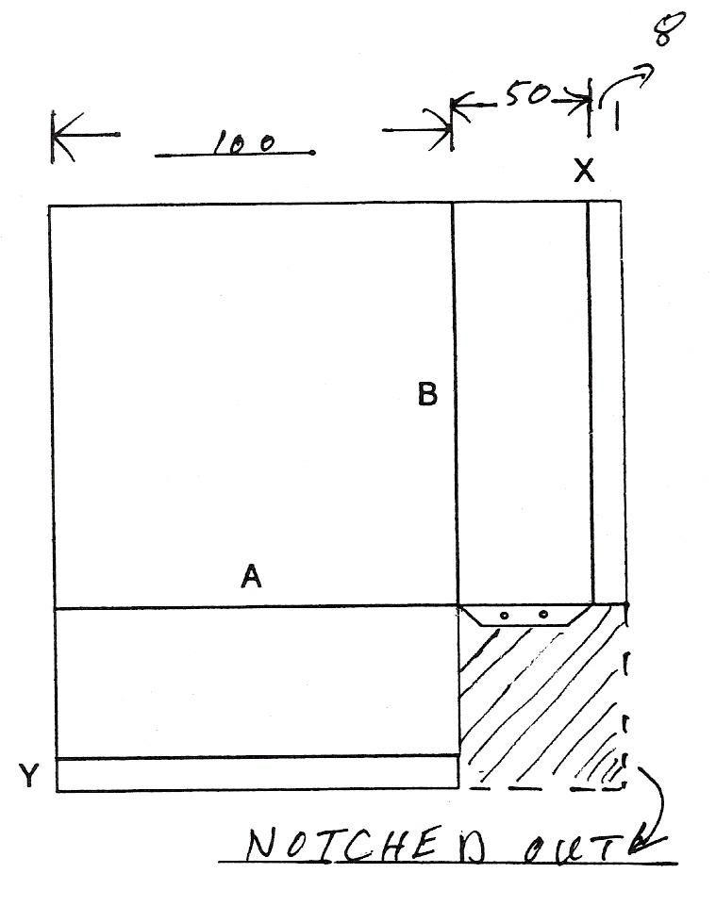
Figure 1 - Tray Assembly

Calculation of blank size is simply done by adding the length of base to the length of side and also allowance for safe edge to be included.
Example: 100 + 50 + 8 = 158

Folding Materials
Folding sheet metal to form edges and seams of various kinds is one of the most important operations in the sheet metal shop. Edges and seams have several purposes.
They are used to improve the appearance of finished projects to strengthen, and to fasten pieces of the metal together.
The equipment on hand and the amount of strain involved play an .important part in selecting the kind of seam used.

Folding Machines
Two types of machines are commonly used in bending or folding metal to form edges or locks for seams; folders and brake presses. The two functions differ in that the width of the bend is limited in the folding machine while in the brake press any width of fold can be made. Each machine will be discussed to familiarise the apprentice with their operation.

Bar Folder
This machine is adapted for bending 22 gauge metal or lighter.
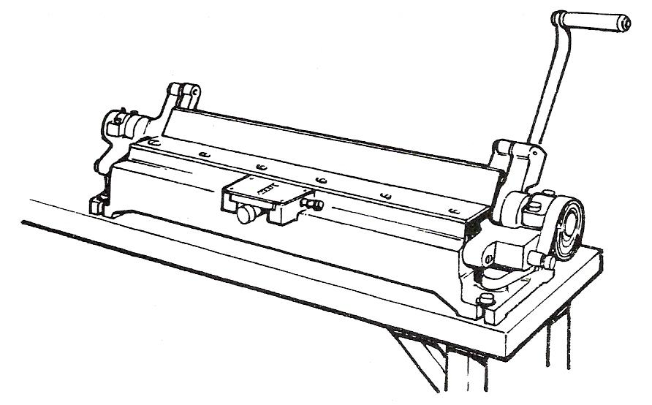
Figure 2 - Bar Folder

Before the apprentice actually begins to operate the folder, he should study the various adjustments and operations of the machine. There are six basic steps that must be remembered when using the folder:
- Allowance for material thickness.
- Sharpness of folder edge.
- Width of lock or edge.
- Adjustment for material thickness.
- Angle of fold.
- Type of material.

Each step should be carefully thought out before forming the edges. After you have turned the edge or lock, it is nearly impossible to flatten it out and turn it in the opposite direction without damaging the metal and spoiling the appearance of the metal.

Allowance for Metal Thickness
When making various types of seams from metal of 26 gauge or lighter, allowance for the thickness of the metal is not necessary. When heavier materials are to be used and accuracy is required, the actual amount of material taken up by the bend or fold must be considered.

The amount necessary depends upon the thickness of the metal and the type of seam or joint. The amount of material to be allowed for the various types of seams will be found under the topic "seaming" which we will deal with later.

Width of Folded Edge
Figure 3 shows the working parts of the folder that controls the width of the folded edge. The gauge fingers are adjusted by the adjusting screw on the graduated scale found on the front of the machine. The gauge adjustment screw moves the fingers forward or backwards to the required width of the lock and the lock screw keeps the gauge from creeping. This gauge is useful for repetition work. The machine has a range for turning edges up to a width of one inch.

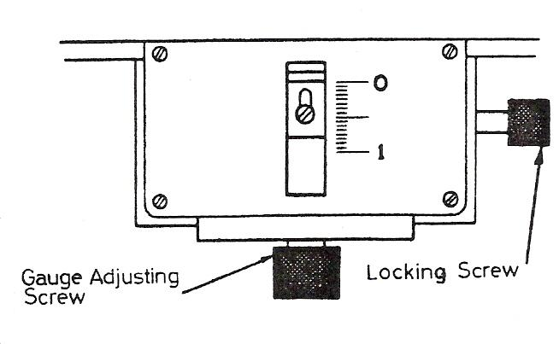
Figure 3 - Width of the Folded Edge

Sharpness of Folded Edge
The sharpness of the folded edge is controlled by lowering or raising the wings. Figure 4 shows the machine set for a sharp fold and then lowered for a thick heavy edge. The wing is adjusted by turning the wedge adjustment screw to the right for a sharp bend and to the left for a round fold.

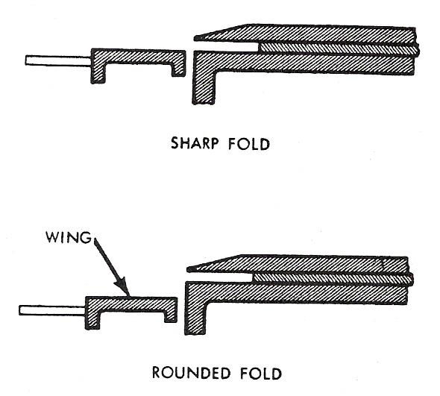
Figure 4 - Sharpness of a Folded Edge

Box and Pan Folders
This type of machine, while suitable for all normal bending and folding operations, has special provisions for bending pans, trays or boxes from a single plate. The forming blades or "fingers" are made in various widths and may be combined in any order enabling any width of tray to be formed within the capacity of the machine.

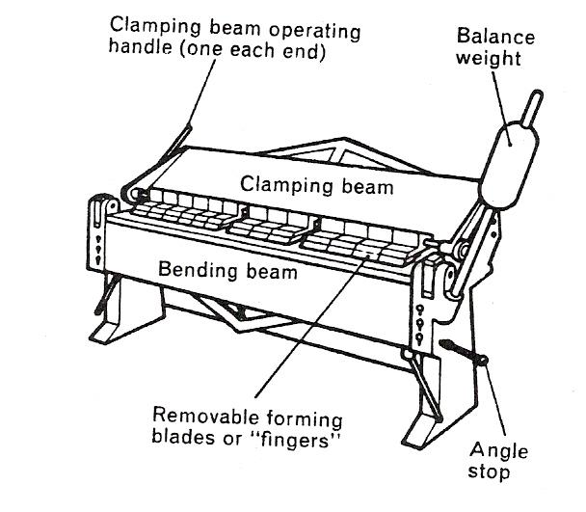
Figure 5 - Box and Pan Folders

Fitting Forming Blades
- Check width of blades required, the size required is the inside measurement of the tray etc.
- Select a suitable combination of blades to give required width.
- Fit blades to machine ensuring they are correctly located in rear slot.

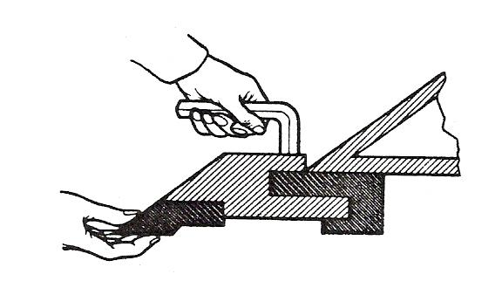
Figure 6 - Fitting Forming Blades

- Tighten pinch screws as each blade is fitted.
- Check overall width of blades.
Repeat operations for various sets of blades.

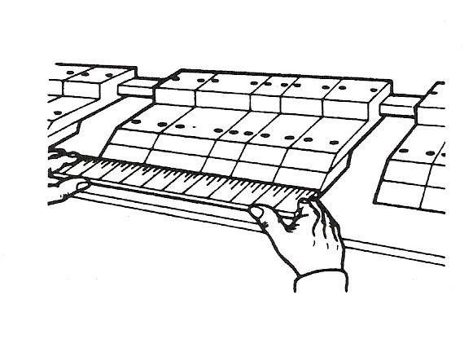
Figure 7 - Check Overall Width of Blades

Setting Angle Stop
- Loosen pinch bolt on angle stop until it is a tight sliding fit on rod.
- Push stop against swivel pins.
- Raise bending beam to required angle, swivel pin will push stop along rod.
- Lower bending beam and tighten stop pinch bolt.

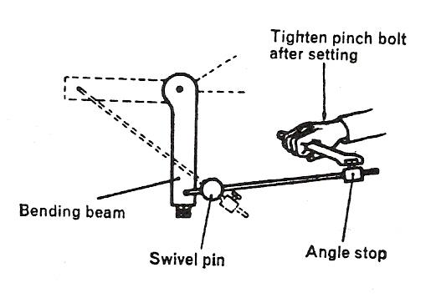
Figure 8 - Setting Angle Stop

Clamping
Clamping beam is operated by two hand levers, each operating independently. One lever need only be operated when working at the end of the machine. Use both levers when clamping full length plates.

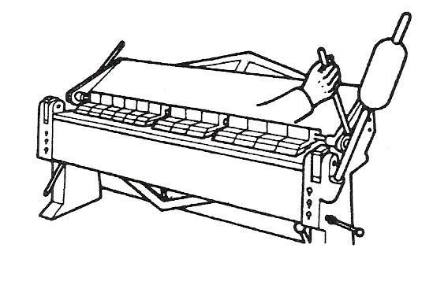
Figure 9 - Clamping

Forming
Where small upstand edges are to be formed, position the plate as shown in Figure 10. Clearance between the machine, bed and clamping beam governs the height of upstand which may be formed by this method of clamping plate.
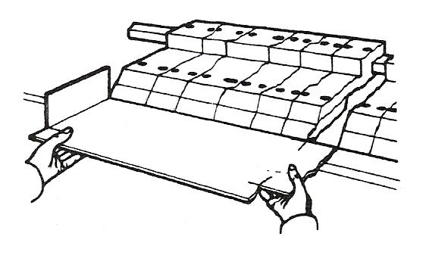
Figure 10 - Forming 1

- Set folding marks against edge of forming blades. Use correct combination of blades.
- Clamp in position using hand lever.
- Raise bending beam to form upstand edge.
- Lower bending beam and release clamping beam.
- Repeat operations 1 & 4 for each side of box.
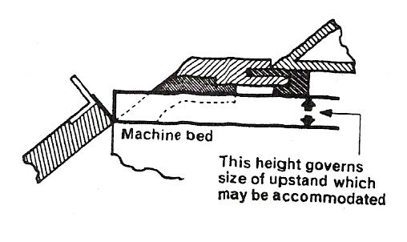
Figure 11 - Forming 2

Note: Where large upstand edges are to be formed, position plate as shown in Figure 12. Distance from the edge of the forming blades to the clamping beam governs the height of the upstand which may be made.
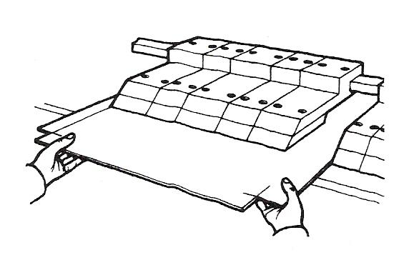
Figure 12 - Forming 3

Safety Hints
It is important that the sheet metal apprentice knows the safe way of operating the machine. Remember the only correct way of operating the machine is the safe way.
- Before using this machine, ensure all blades are securely fitted.
- Do not place your hand in the folding machine when someone else is operating the handle.
- When operating the folding machine, see that no one else is near enough to the counterbalance weights to be hit by them.
- If you are standing in front of the folding machine, stand well back so that you will not be struck by the handles that project from the bending beam when it is swung up.
- Never swing on counter weights.
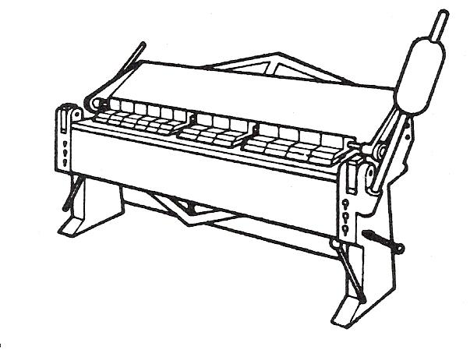
Figure 13 - Safety Hints

Squeezing a Turned Edge
The method of squeezing a turned edge or closing a seam can be seen in Figure 14.
The seam is inserted between the clamping blades and the clamping handle is pulled forward as far as possible, closing the seam.
When forming heavy gauge metal the bending leaf is adjusted to take the metal thickness.
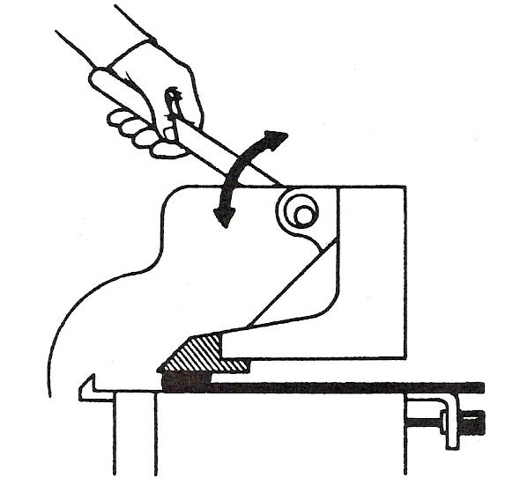
Figure 14 - Squeezing a Turned Edge

Care of the Folding Machine
- Never bend rod or wire in the machine.
- Pound on metal in the machine with a wooden or rubber mallet only.
- To obtain proper functioning, the machine should be levelled and bolted to the floor.
- Oil all moving parts of the machine as the manufacturer recommends.
- The capacity of the machine is given on a plate on the machine.
- When bending heavy metal for seams and similar operations, remember that you can gain considerable mechanical advantage through the leverage principle by clamping down the handle nearest the work first and then clamping down the other handle.
- Do not use pipe extensions on the brake handles to clamp down the work. This will overstrain the machine.

Drawing Symbols

Oblique Projection
This projection is the simplest method of constructing a pictorial drawing as the curves do not require construction. Oblique projection is the least pleasing pictorially and much detail is lost in the foreshortening that occurs.

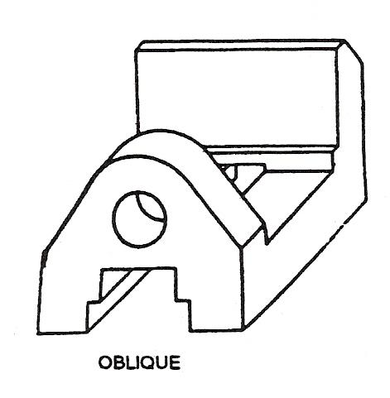
Figure 15 - Techniques of Drawing - Oblique

Isometric Projection
This projection is the pictorial technique most widely used by engineering draughtsmen. Despite the fact that all the circles and curves have to be constructed, it is quick and relatively simple compared with perspective drawing. Isometric projection gives a reasonably proportioned, pictorial projection even when the receding lines are drawn the true length.

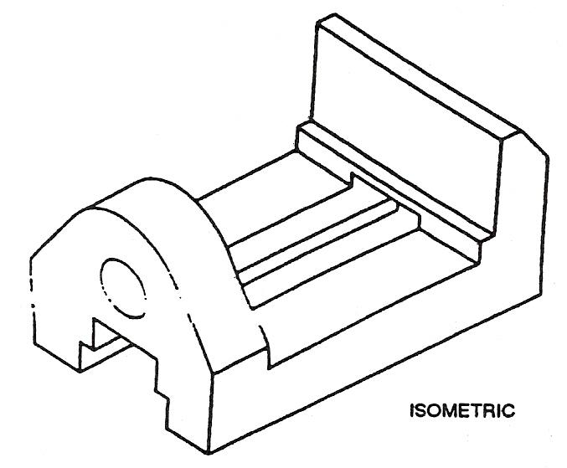
Figure 16 – Techniques of Drawing - Isometric

Making and Notching Simple Patterns
Though the patterns the sheet metal worker lays out may vary, the steps by which the patterns are developed remain the same. By applying the following rules in the process of laying out, you will avoid both waste and errors.
- Check the sheet on which the pattern is to be laid. Sometimes the bottom of a sheet can be bowed or warped Check the edge with a straight edge since any warping or bowing will affect the accuracy of the finished job.
- Square up the left hand edge of the sheet.
The edges of the sheet are seldom perfectly square. Therefore it is necessary on any layout to square the left hand end of the sheet to the bottom edge. The usual method is to use a large square and scribe a line say ¼" or 6mm from the left edge using the bottom as the datum edge.
- Economy in laying out.
One of the chief characteristics of a true craftsman in any trade is the ability to do a job with the least amount of material. When the pattern is being laid out choose the lower left hand corner of the sheet as this will leave the metal above and on the right of the pattern, usable for other patterns.
- Take measurements from datum lines.
The line measurements shown in Figure 17 would be taken from left to right and from the bottom up. Never try to cut the metal to size before making the layout. Use as large a piece as possible as this will aid in avoiding errors etc.

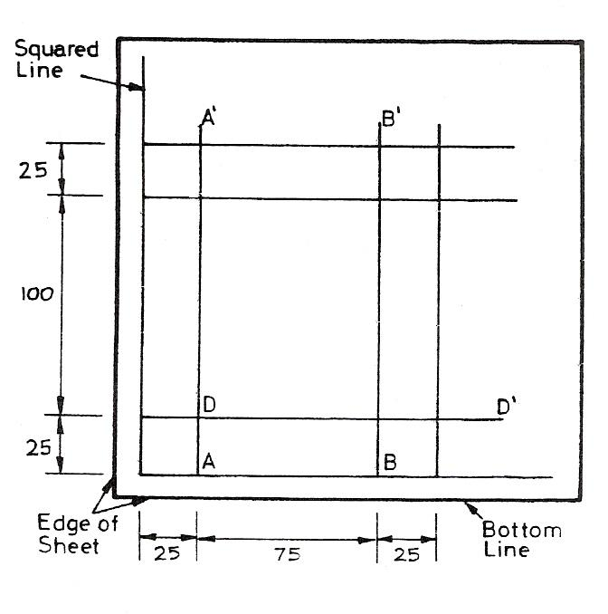
Figure 17 - Take Measurements from Datum Lines

- Make measurements at both ends of each line and draw a line through the two points. Normally, only one line at the left hand end of the sheet is squared. Do not try to square other lines from the edges as would be done in mechanical drafting.
If line AA' is to be 25mm from the square line, the proper method is to measure 25mm at A and 25mm A' and then draw a line through these two points. Line BB' is 75mm from AA' so a line should be drawn 75 mm from A and A' through these two points.
The horizontal lines such as DD are handled in the same way. 25mm is measured from the bottom line at DD and the line is drawn through the two points.
- Draw in all vertical and horizontal lines. Then add lines for notches, seams, edges and laps. If all vertical and then horizontal lines are drawn, the basic pattern is then complete. Be sure that all lines are drawn before starting to cut out the pattern.
- Before starting to form the pattern, make sure all fold or bend lines are marked on the pattern. Do not depend on the corner of notches for bend lines.
- Study the shape of basic patterns.
Box patterns may be in a variety of shapes and sizes and may use different seams and edges. One of the most important tasks of the sheet metal worker is to visualise the finished job from the flat pattern.
- After you have made the layout, check the overall dimensions on each side of the pattern. This is particularly important on patterns drawn with parallel lines. When the parallel line method of development is used, the width of the pattern at the top and bottom should obviously be the same. If they vary more than 1/16" (1.5mm), this indicates an error in measurement. The golden rule is, check your measurements twice and cut once.

Application of Various Types of Lines
The general engineering drawing the following types of lines should be used:
Examples (letters refer to Figure 18) | Type of Line | Line Width | Example of Application
A | Continuous (thick) | mm  0.7 | Visible outlines
B | Continuous (thin) | 0.3 | Dimension, projection extension, leader hatching and fold lines
C | Continuous irregular (thin) | 0.3 | Break Lines (other than on an axis)
D | Short dashes (thin) | 0.3 | Hidden outlines
E | Chain (line) | 0.3 | Centre Lines
F  | Chain (thicker at ends and at changes of direction than elsewhere) | 0.7 | Cutting Planes
G | Chain (thick) | 0.7 | Indication of surfaces which have to meet special requirements
Table 1 - Application of Various Types of Lines

Dashed Lines
Dashed lines should comprise of consistent length and spacing approximately to the proportion shown in the examples in Table 1.

Thin Chain Lines
The chain lines should comprise long dashes alternating with short dashes. The proportions should be generally as shown in Table 1 but the lengths and spacing may be increased for very long lines.

Thick Chain Lines
The lengths and spacing of the elements of thick chain lines should be similar to those of thin chain lines.

General
All chain lines should start and finish with a long dash and when thin chain lines are used as centre lines they should cross one another at solid portions of the line. Centre lines should extend only a short distance beyond the feature unless required for dimensions or other purposes. They should not extend through the spaces between views and should not terminate at another line of the drawing. Where angles are formed in chain lines, long dashes should meet at corners. Arcs should join at tangent points. Dashed lines should also meet at corners and tangent points with dashes.

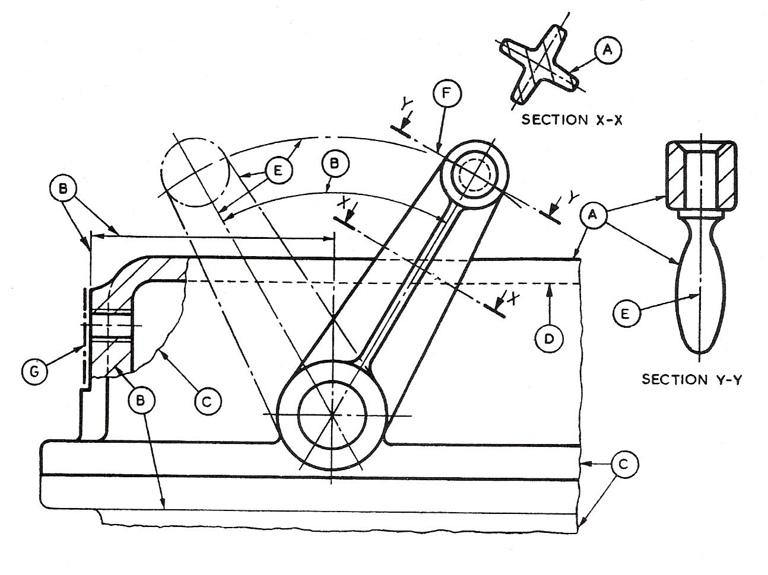
Figure 18 - Various Types of Lines

Scale Drawings

Scales
Quite frequently you will find that the views of a machine part and certainly those of a building are too large to be drawn on your drawing sheet full size.
Such views would need to be drawn 'to scale', that is proportionally reduced in size to suit the size of the sheet on which the drawing is to be made.
Some reduction scale ratios are:

Metric
1:2 ; 1:5 ; 1:10 ; 1:20 ; 1:50.
1:100 ; 1:200 ; 1:500 ; 1:1000.

Example – 1:2 ; 1:5 ; 1:10 – Detailed drawings
1:50 – House Plans

Scale multipliers and dividers of 2 and 5 and 10 are recommended. The scale of the drawing should be indicated in the same manner, e.g. 10:1 on a drawing at ten times full size.

Imperial
Full size (1/1) 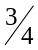 in. = 1 ft. (1/16)
Half full size (1/2) 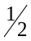 in. = 1 ft. (1/24)
3 in. = 1 ft. (1/4) 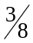 in. = 1 ft. (1/32)
1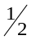 in. = 1 ft. (1/8) 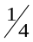 in. = 1 ft. (1/48)
1 in. = 1 ft. (1/12) 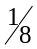 in. = 1 ft. (1/96)
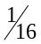 in. = 1 ft. (1/192)

All the above scales with the exception of 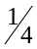 in. = 1 ft., in. = 1 ft. and in. = 1 ft. can be used for detailed drawings. In the majority of cases the latter three scales are used for general arrangement drawing and house plans.
Alternatively some parts will be so small that full size views would not show the details of dimensions. Therefore these views are proportionally enlarged.
Full size and enlargement scale ratios are:

Metric
1:1 ; 2:1 ; 5:1 ; 10:1 etc.
Imperial
1:1 ; 2:1 ; 4:1 etc.

First Angle Projection
The pictorial drawing in Figure 19 indicates the shape of the component with a single view.

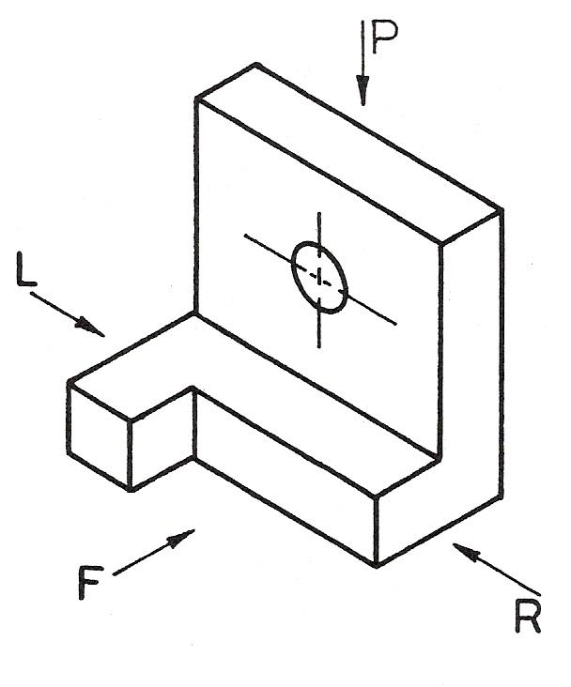
Figure 19 - Shape of the Component with a Single View

An orthographic drawing indicates the shape of a component by using a number of views each looking at a different face of the component.
At least two views are necessary to fully represent the component. Usually, however, three views are shown in order to clarify internal and external detail.
- Front view
- Plan view
- Side view
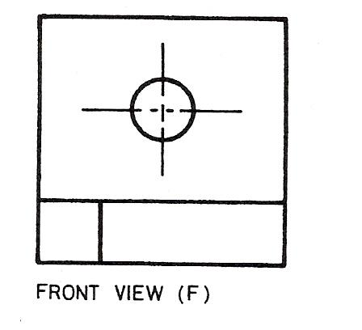

- The front view, or front elevation, represents what is seen when looking at the front of the component in Figure 19 in the direction of arrow F.
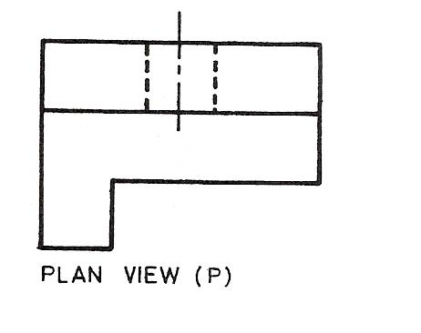
- The plan view represents what is seen when looking at the top of the component in the direction of arrow P at 90º to arrow F.
- A side view, or side elevation, represents what is seen when looking at the side of the component in the direction of either arrow R or arrow L. These arrows are at 90º to both arrow F and arrow P.
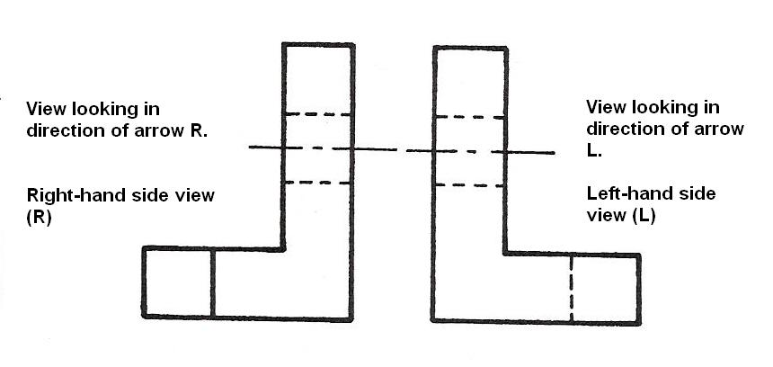
The separate views of the component are combined to form a complete orthographic drawing as shown in Figure 20.
The front and side views are drawn in line with each other so that the side view may be “projected” from the front view and vice versa.
The plan view is drawn in line with and below the front view. In other words, the plan is projected from the front view.
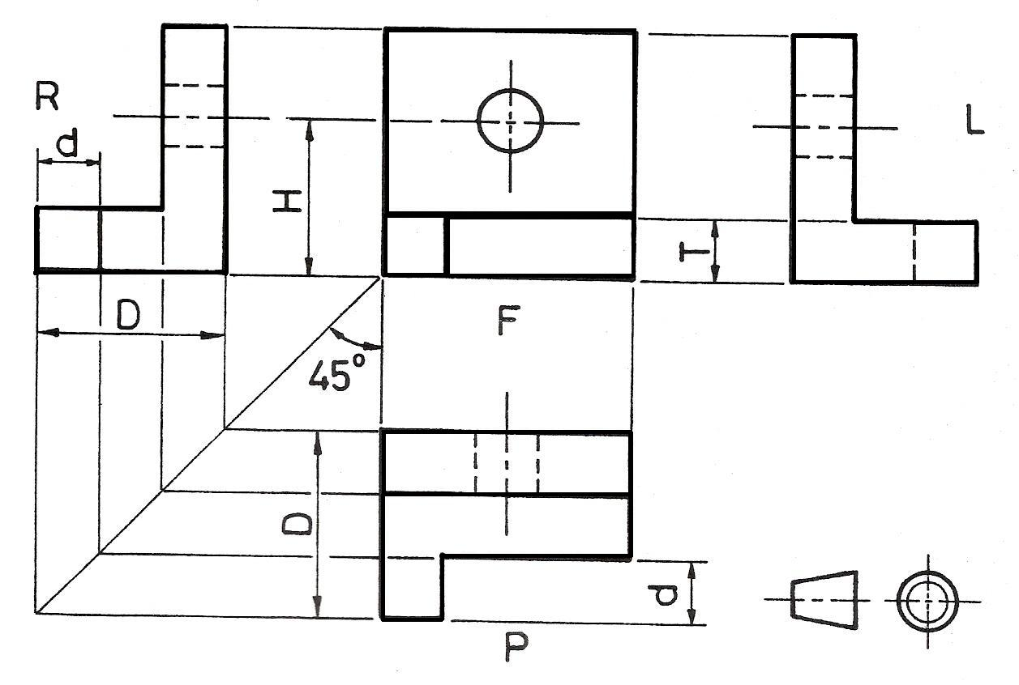
Figure 20 - Complete Orthographic Drawing
Points to note when making a drawing using First Angle Orthographic Projection:
- Corresponding heights in the front view and side view are the same.
For example, the height of the hole from the base, H, is the same in both front and side views.
The thickness of the base, T, is the same in both front and side views.
- Widths in the side view correspond to depths in the plan.
For example, the total width, D, in the side view is the same as the total depth, D, in the plan.
The width, d, is the same in both plan and side views.
Projection of widths from side view to plan is made easier by using the 45º swing line as shown in Figure 20.
- The plan view is usually projected BELOW the front view.
It can be above but this would be called an "inverted" plan.
- The R.H. side view is shown on the L.H. side of the front view.
The L.H. side view is shown on the R.H. side of the front view.
Note: Drawings should be read (or interpreted) by viewing from the R.H. side or bottom R.H. corner of the drawing.

The orthographic drawing of the bracket, Figure 20, was constructed step by step as follows:
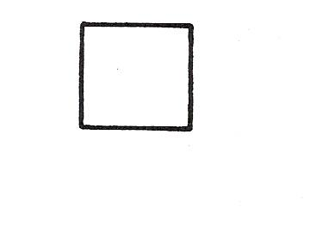
Step 1. The face to be used as the front view of the component was chosen, in this case, looking in the direction of arrow F (Figure 19). The selection of the front view is purely arbitrary.
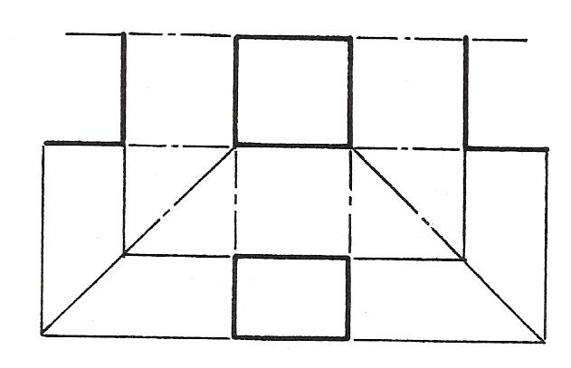
Step 2. The outline of the front view was drawn FAINTLY in the position shown opposite leaving room on the drawing sheet for a plan view and also both end views to be added.
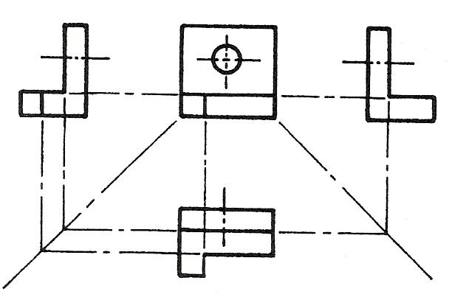
Step3. The outlines of the plan view and side views were projected FAINTLY from the front view and positioned as shown opposite.
Step 4. All remaining external details were added and centre lines inserted as shown opposite.
Step 5. All hidden detail, i.e. for hole and recess, was added and the outline “heavied-in” to complete the drawing a shown in Figure 20.

Third Angle Projection
You may remember from information presented earlier in the text that there are two methods of orthographic projection used in the preparation of engineering drawings.
You should, by now, be quite conversant with one of them - First Angle Orthographic Projection. The other is known as Third Angle Orthographic Projection.
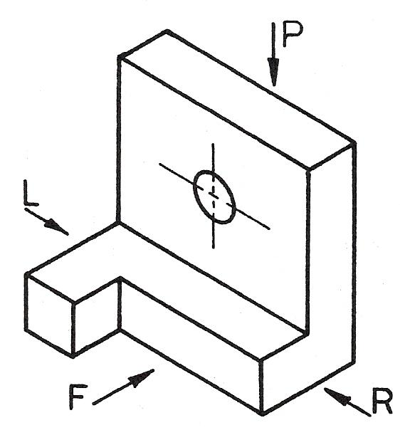
Figure 21 - First Angle Orthographic Projection

In Third Angle Orthographic Projection the individual views are placed on the drawing sheet in projection with each other as shown in the following graphic.
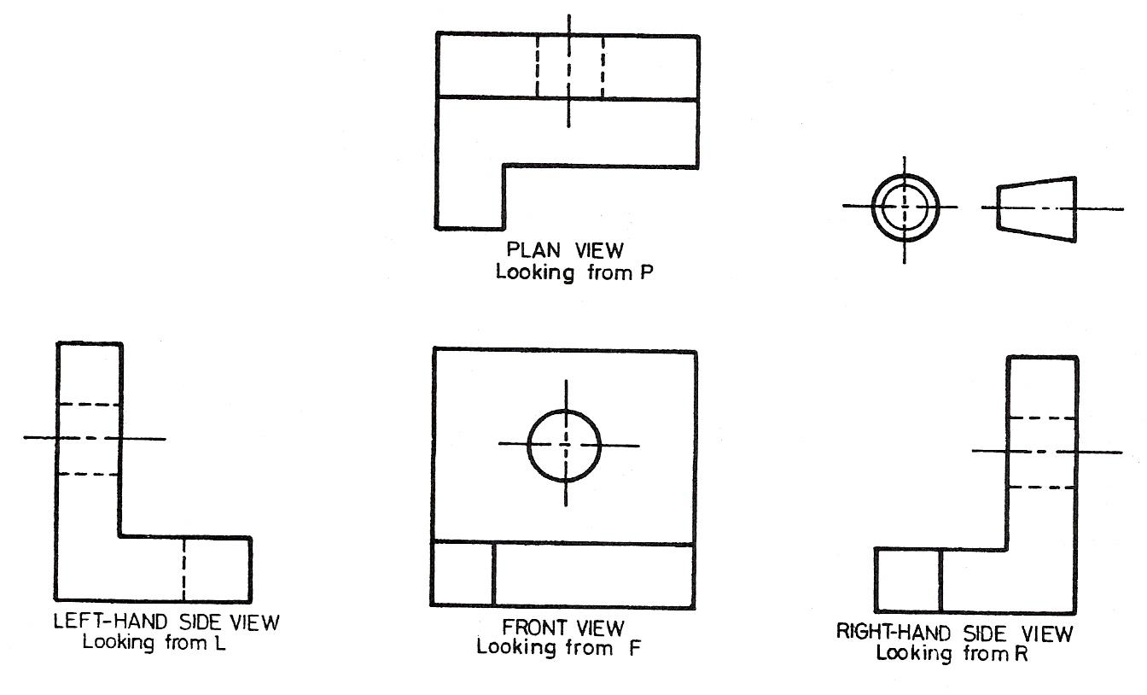
Figure 22 - Third Angle Orthographic Projection

Special points to note:
- The plan is always projected ABOVE the front view.
- The right-hand side view is shown on the RIGHT-hand side of the front view.
- The left-hand side view is shown on the LEFT-hand side of the front view.

Terminology
Many different types of hole~ may be seen on engineering drawings. The more common ones, associated with drilling, reaming and/or tapping, are shown below in Fig. 1. The name and where appropriate the application of each is indicated.
Figures 2 and 3 indicate the different terms which may be seen on drawings that are associated particularly with lathe work.

- A drilled hole or, if greater accuracy is required, a reamed hole,
- A ‘blind’ tapped hole i.e. a threaded hole which passes only part way through the plate.
- A countersunk hole. Provides a mating seat for a countersunk headed screw or rivet.
- A counterbore. Provides a ‘housing’ for the heads of capscrews, bolts, etc.
- A spotface. A much shallower circular recess. Provides a machined seat for nuts, bolt heads, washers, etc.

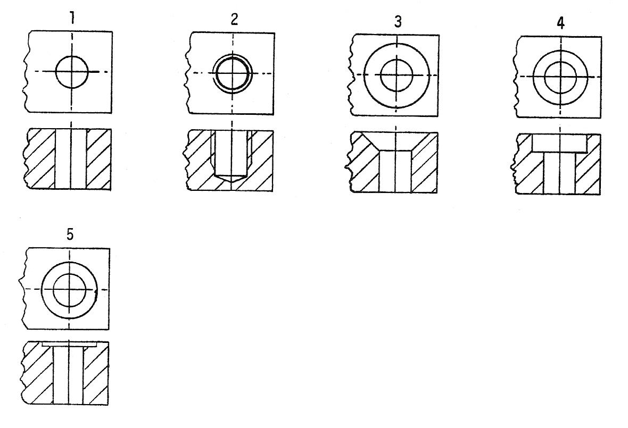
Figure 23 - Types of Holes

Abbreviations
Many terms and expressions in engineering need to be written on drawings so frequently as to justify the use of abbreviations which help to reduce drafting time and costs. Many of these abbreviations have been standardised as can be seen in BS 308:1972: section 11.
A selection of the more commonly used ones are stated and clarified in the following table.
Abbreviation | Meaning | Sketch/Notes
A/F | Across corners | 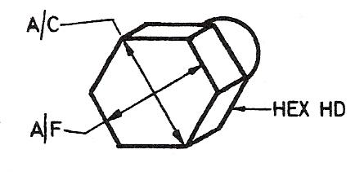
A/C | Across flats
HEX HD | Hexagon head
ASSY | Assembly
CRS | Centres | 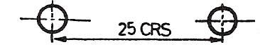
or CL | Centre line | 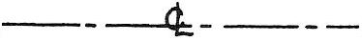
CHAM | Chamfered | 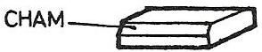
CH HD | Cheese head | 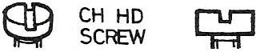
CSK | Countersunk | 
C’BORE | Counterbore | 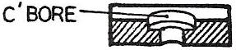
CYL | Cylinder or cylindrical
DIA | Diameter (in a note) | 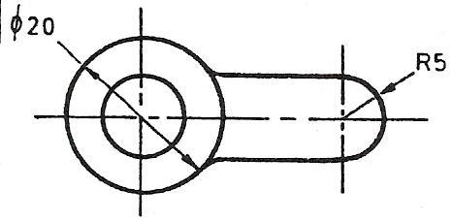
 | Diameter (preceding a dimension)
R | Radius (preceding a dimension, capital only)
DRG | Drawing
FIG | Figure
LH | Left Hand
LG | Long
MATL | Material
NO | Number
Table 2 - Abbreviations

Drilling Maching Operation

Safety – Drilling Machines
Safe operation of drilling machines involves applying normal safe working procedures and taking extra care to avoid the particular hazards associated with drilling operations.
FIG shown below demonstrates some unsafe working hazards.

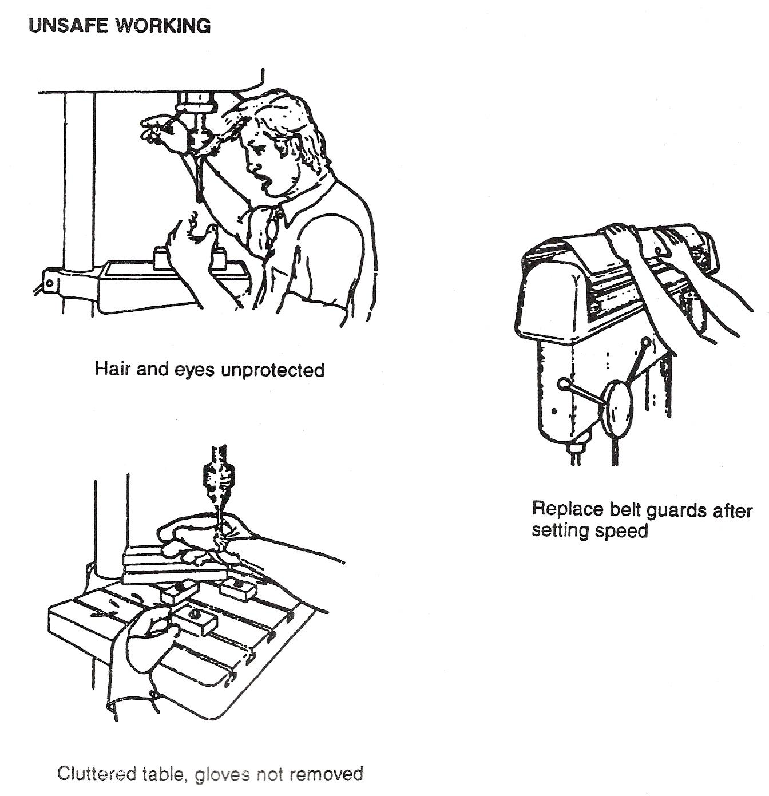
Figure 24 - Unsafe Working

Care of Drilling Machines
There are two requirements for the continued efficient operation of drilling machines:
- They must be used correctly
- They must be given regular cleaning, lubrication and maintenance

The main precautions to be observed when using a drilling machine are:
- Do not overload the machine by using drills of excessive diameter;
or
- By using feeds so heavy that the drilling head is deflected appreciably.

- Do not subject the machine to shock by ramming the drill into the work;
or
- By allowing the spindle to jar on the back stroke.

The following are indications that adjustments or repairs are necessary to the machine:
- The spindle wobbles - the worn bearings need to be replaced.
- The spindle has excessive end play - the feed mechanism must be adjusted to reduce backlash.
- Holes being drilled not at right angles to work surface - the worktable needs adjustment.

Pop Riveting
Pop rivets, unlike solid rivets, are tubular and are much lighter in weight. They are manufactured from either aluminium alloy for lightness or nickel for additional strength and corrosion resistance. They were originally designed for one-sided riveting, by which rivets can be set in places otherwise inaccessible. One operator is needed, the rivets being set or clinched with the aid of special hand-held 'lazy tongs' or pliers. Although their main application has been in aircraft construction and motor vehicle body building, where it is necessary to join thin material to thicker supporting members and lightness is important, they are often used in place of solid rivets for general riveting. They are available in diameters 2·4 mm, 3·2 mm, 4 mm and 4·8 mm for joining thicknesses up to 12·7 mm.
A skilled operator may achieve speeds of 20 rivets per minute.

Blind Rivets
Blind rivets or pop rivets as they are commonly known are so called because they may be installed completely from one side of the work. This convenience has caused a wide spread popularity for blind riveting. The riveting operation is performed by one operation using a pop rivet tool i.e. pneumatic gun, lazy tongs, hand pop gun. A mandrel runs through the rivet. Just under the head the mandrel is weakened to provide a breaking point.
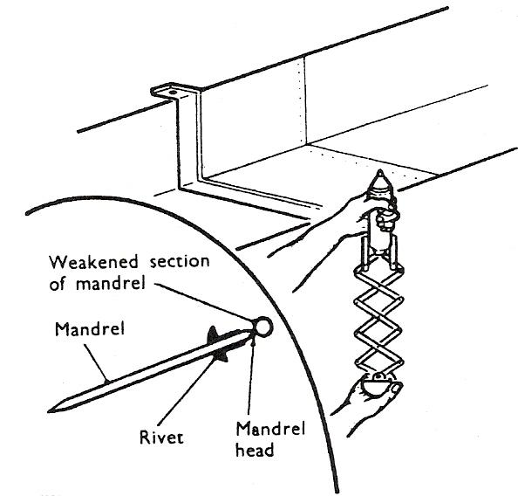
Figure 25 - Blind Rivets

Forming of Rivet Head
The rivet is formed by pulling the mandrel through the rivet using the pop rivet gun. As the mandrel is pulled through, the head is drawn into the rivet, expanding it outwards. Pulling further on the tool increases the tension on the mandrel and causes it to break and allowing it to be drawn from the rivet.

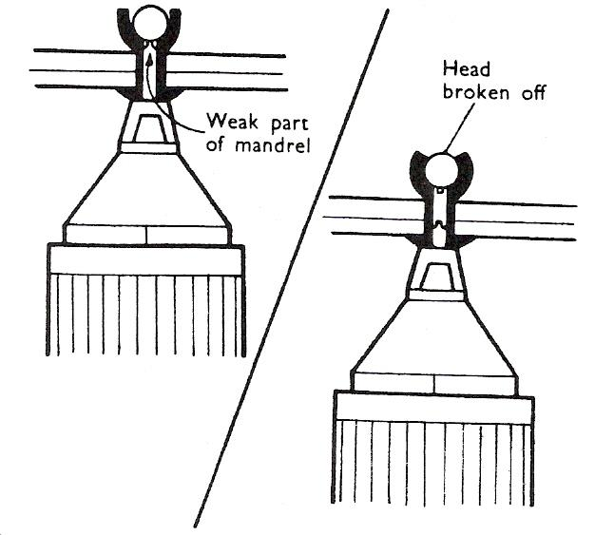
Figure 26 - Forming of a Rivet Head

Use of Lazy Tongs for Pop Riveting
Lazy tongs are used for the larger diameters of rivets, where sufficient working space is available to permit operation of the tool.
The construction of the tool permits a moderate pressure on the handle to provide a strong pulling force on the rivet mandrel.
- Check before use:
  - That the correct collet and nosepiece is fitted. Lazy tongs will not grip the rivet mandrel if the wrong size collet is in use.
  - Rivet will not enter the collet if an old mandrel has not been removed.

Safety
Before use, check that the lazy tongs are in good order. Pay particular attention to the condition and security of the pins linking the levers.
Failure of a pin can throw the levers out of alignment with danger of the arms or body being nipped.

Riveting
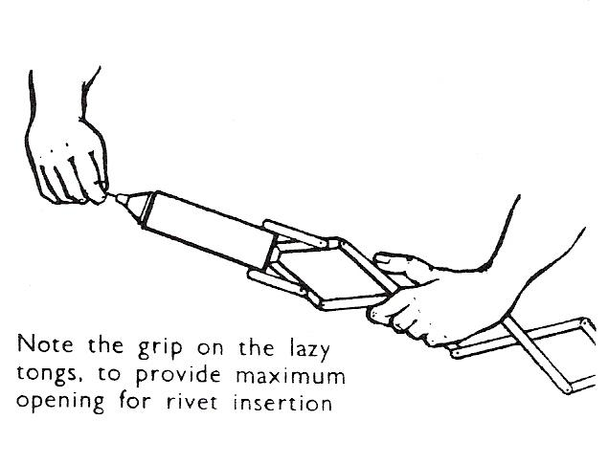
- Open lazy tongs fully, hold open as shown opposite, against light spring pressure exerted by the tool.
- Insert rivet, push until rivet rests against nosepiece.
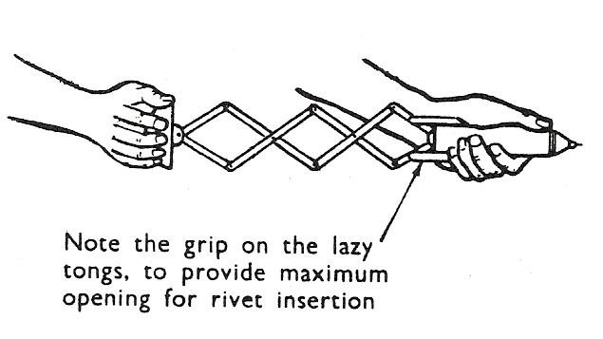
- Change grip to barrel and with the other hand close lazy tongs until resistance is felt. Do not close any more, otherwise head will start to form and the rivet will not enter the hole.
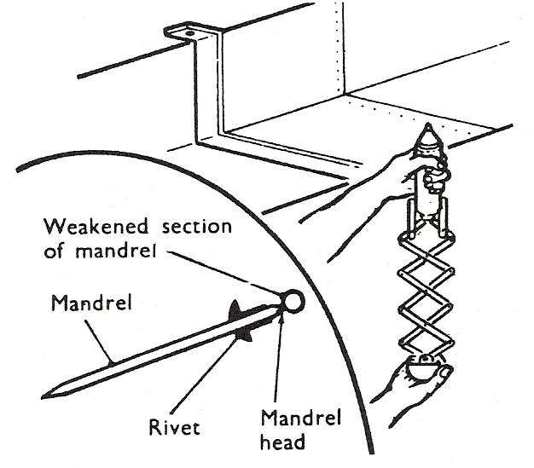
- Insert rivet in previously drilled hole. Maintain lazy tongs square to the sheet surface. Apply upward pressure on handle.
- Continue upward pressure until the mandrel snaps at the weak section.
Withdraw lazy tongs.
Open lazy tongs fully to eject used mandrel and fit new rivet.

Safety
Used mandrels should be collected in an old box.
An accumulation of loose mandrels provides a dangerous footing, especially on scaffolding platforms.

Use of Plier Riveting Tool
Riveting in confined spaces requires the use of a plier type riveting tool. These are unsuitable for larger dimensions of rivets due to the reduced amount of leverage available.
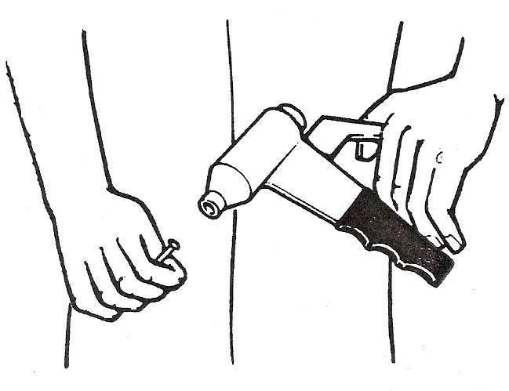
Figure 27 - Use of Plier Riveting Tool

Use fingers to open tool fully against light spring pressure.
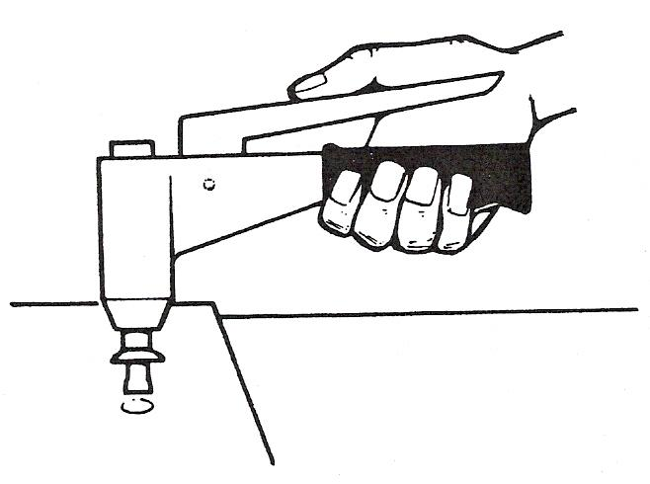
- Insert rivet.
- Transfer fingers to body grip.
- Insert rivet in required hole.
- Close rivet by squeezing operating handle until mandrel snaps.
- Continue operation as for lazy tongs
(See previous section).

Pneumatic (air) Pop Gun
This gun is about the easiest and quickest one to use of the pop guns available.
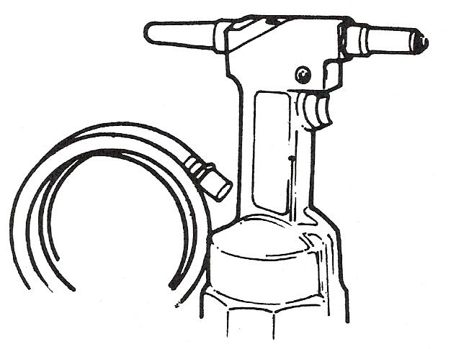
- Insert rivet in gun.
- Position index finger over trigger.
- Insert rivet in required hole.
- Close rivet by squeezing trigger until mandrel snaps.
- Allow mandrel to fall free.

Self Assessment
Questions on Background Notes – Module 1.Unit 8

1. Why would you manufacture a 3-piece box rather than a one piece?

2. Why do we notch patterns?

Answers to Questions 1-2. Module 1.Unit 8

1.

It can reduce scrap by reducing notching, also it can save time.

2.

Sometimes part of the metal in the job may get in the way, so
we remove that portion to prevent overlapping and bulging
of the seams, edges or any other part of the job.

Index

A
Abbreviations, 33
Application of Various Types of Lines, 24
Dashed Lines, 24
General, 26
Thick Chain Lines, 25
Thin Chain Lines, 24
D
Drawing Symbols, 21
Isometric Projection, 21
Oblique Projection, 21
Drilling Maching Operation, 34
Care of Drilling Machines, 35
Safety - Drilling Machines, 34
F
First Angle Projection, 28
Folding Materials, 11
Allowance for Metal Thickness, 12
Bar Folder, 11
Box and Pan Folders, 13
Care of the Folding Machine, 20
Clamping, 16
Fitting Forming Blades, 15
Folding Machines, 11
Forming, 17
Safety Hints, 18
Setting Angle Stop, 16
Sharpness of Folded Edge, 13
Squeezing a Turned Edge, 18
Width of Folded Edge, 12
M
Making and Notching Simple Patterns, 22
P
Pop Riveting, 36
Blind Rivets, 36
Forming of Rivet Head, 37
Pneumatic (air) Pop Gun, 39
Riveting, 38
Use of Lazy Tongs for Pop Riveting, 37
Use of Plier Riveting Tool, 39
Procedure for Tray Assembly, 10
S
Scale Drawings, 27
Scales, 27
T
Terminology, 32
Third Angle Projection, 31

